Asthma Hospitalizations vs. CA Interstates
Merissa Coello | Paulina Close | GSP 270 Project | April 28, 2016

Abstract
The role air pollution plays in initiating asthma is still under investigation and likely involves a complex set of interactions between indoor and outdoor environmental exposures and individual genetic susceptibility. This project looks into the coloration between interstates and asthmas rates per county within California.
We performed analysis from inspection after using tools repeated to narrow down our data and counties of interest. Some of those tools were the Field Calculator and select by attribute. The most used tool was creating a new layer from specified data. The ten counties with the highest rates of asthma hospitalization were narrowed down. Humboldt County is listed in the top ten counties with the highest asthma rates. In this project, we analyzed and compared asthma hospitalizations in California with traffic volume on interstates and determined that there is no direct coloration between asthma rates and interstates.

Introduction
According to the California Environmental Protection Agency or EPA Air Resources Board on Asthma and Air Pollution, a survey performed in 2010 found that the fraction of Americans ever diagnosed with asthma has been increasing in recent years. In addition, nearly “692,000” California children reported experiencing current asthma symptoms (EPA, 2016). The EPA Asthma and Air Pollution Board goes onto describe triggers of asthma, these include pollens, dust mites, animal dander, and fragrances, and air pollution. The role air pollution plays in asthma is still under investigation. The EPA states it likely involves a complex set of interactions between indoor and outdoor environmental exposures and individual genetic susceptibility.
This team hypothesizes there is a direct correlation between asthma rates and interstates. The objective of this project is to use geospatial analysis to determine if there is a correlation between asthma hospitalizations by county and interstates in California.

Methods
A complete list of datasets used can be seen in Table 1. A data set of “Asthma ED Visits Rates by County 2012” was downloaded from the California Department of Public Health Geospatial Resources website. A shapefile of “State Highway Network/Postmile System” and “Traffic Volumes (AADT)”was downloaded from Caltrans GIS Highway Data.

Table 1: Complete table of datasets used in analysis
Dataset | Description | Data Source | Link to Source
Asthma Hospitalization | Asthma Hospitalizations by County in California | California Department of Public Health Geospatial Resources | http://maps.cdphdata.opendata.arcgis.com/datasets/8e88ece687a847daa1f2db6063b5b81a_0
State Highway Network (SHN) and Postmile System | Highway Networks in California | Caltrans GIS Highway Data | http://www.dot.ca.gov/hq/tsip/gis/datalibrary/Metadata/StateHighway.html
Traffic Volumes (AADT) | Traffic Volumes in California | Caltrans GIS Highway Data | http://www.dot.ca.gov/hq/tsip/gis/datalibrary/Metadata/AADT.html
California population by County | Population by County in California | US-Places | http://www.us-places.com/California/population-by-County.htm

The data spans across California and therefore needed to be in a suitable spatial reference. The datasets were batch projected into the North American Datum or NAD 1927, California (Teale) Albers (Meters) coordinate system. To begin, we started on the “State Highway Network/Postmile System” shapefile. The select by attribute tool was used and all interstates were selected. A new shapefile was created from the interstates and named “Interstates”. The “Traffic Volumes (AADT)” was next. By looking in the metadata, we were able to see AADT stood for annual average daily traffic. The Select by attribute tool was used again to select “Back_AADT” and “Ahead_AADT”. A layer was created from select features and both “Back_AADT” and “Ahead_AADT” were summed into one field. Within this new selection, the select by location tool was used to select points within five meters of an interstate. A new shapefile was created called “Traffic_On_Interstate”.
The asthma shapefile was worked on next. An attribute table with California population by county was manually entered. The population’s numbers were used from US-places.com. Another attribute table was added and named “Pop_Asthma”, this indicated percent of population with asthma. The Field Calculator tool was used to divide populations by asthma hospitalizations to find the population percentage. The “Pop_Asthma”, now filled with data, was turned into a shapefile. The top ten counties with the highest percentage of asthma were intersected with the “Traffic Interstate” shapefile. The dissolved tool was used to dissolve by county and the traffic volume was summed. A new shapefile was created called “Traffic_Per_County”.
Fourmaps were made in total. A map with top ten counties that have the highest rates of asthma hospitalizations, a map showing a comparison to the California Breathing Organization’s top ten asthma counties, interstate traffic through counties, and a map focused on a cluster of counties with the high rates of asthma hospitalization. The maps listed will be presented below in the results section. A flowchart of the methods described is included below as Figure 1.

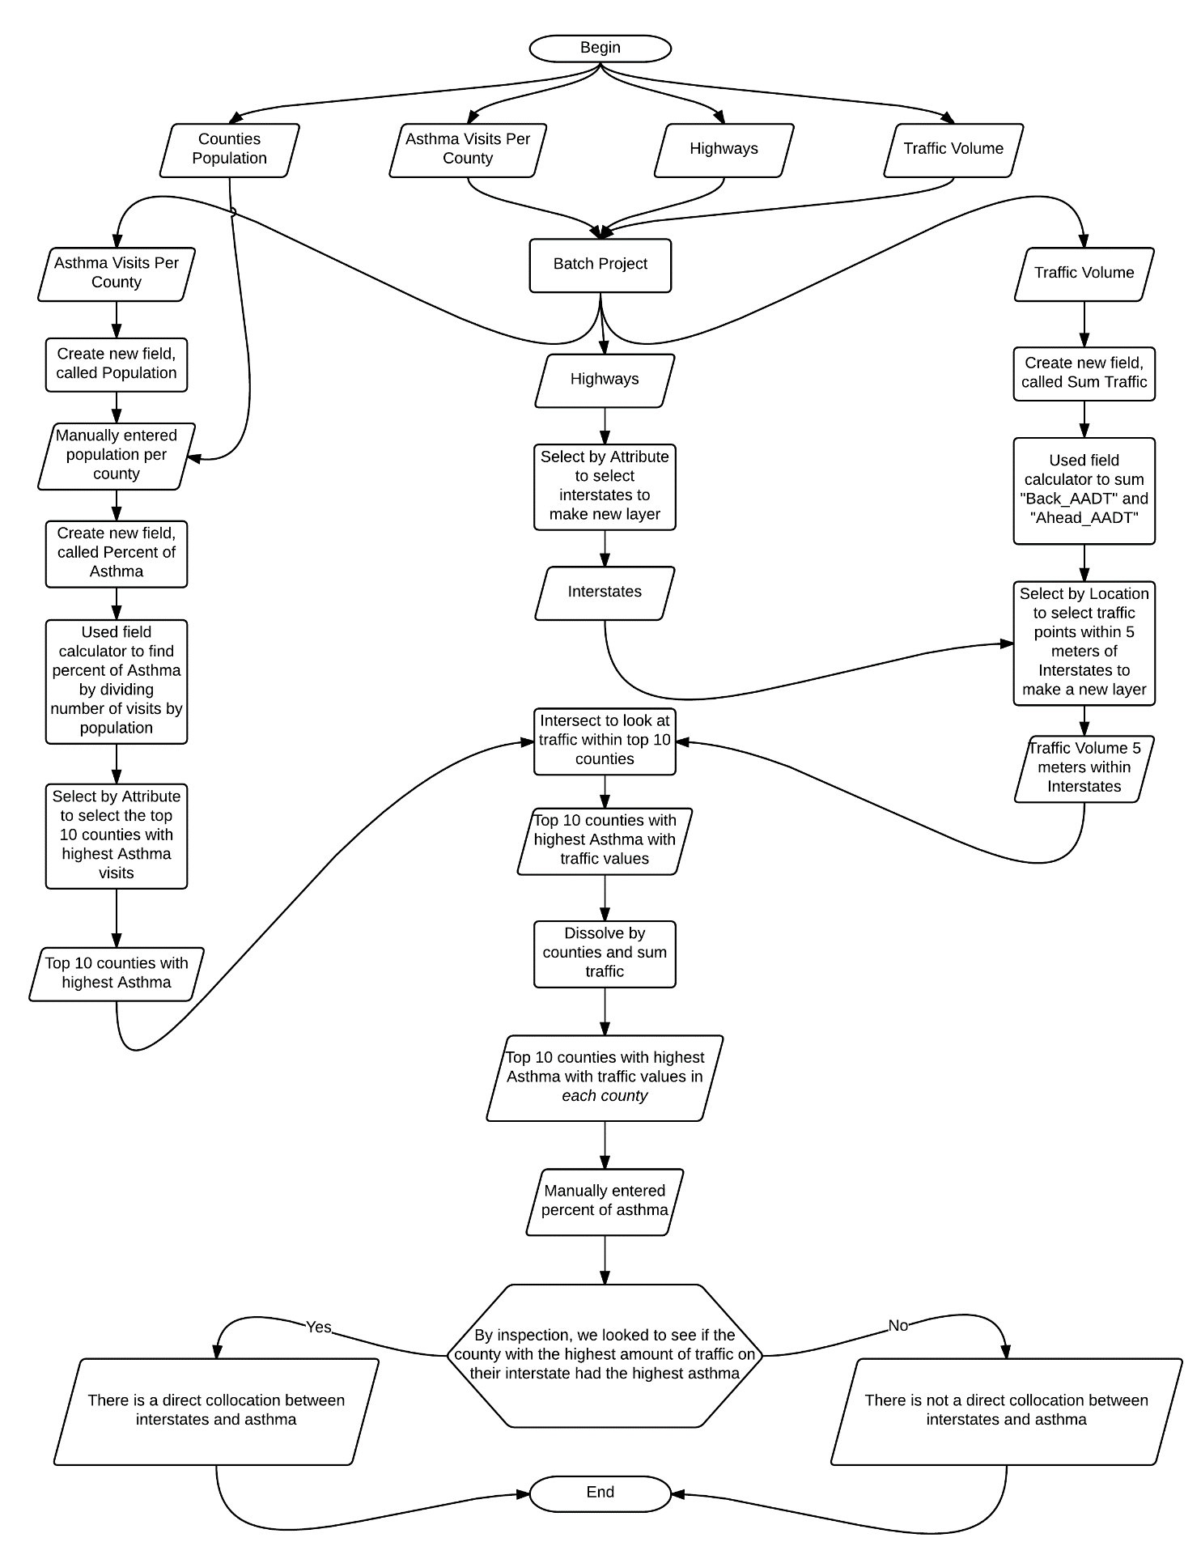
Figure 1: A flowchart for the methods used in this project

Results
Our hypothesis was proven wrong during our analysis. After we narrowed down the top ten counties with the highest asthma we found that half of these top ten counties did not have interstates running through them. We were left with top five counties that with interstates. We then focused on the county with the highest asthma rates. Through inspection, we determined if this county had a higher traffic amount than the rest of the top four counties. The county with the highest asthma rates is King County, and this county did not have a highest traffic volume. A table of the top ten counties with highest asthma rates and their relative traffic values is included below as Table 2. This tells us, through our analysis; there is not a direct correlation between interstates and asthma.

Table 2: Top ten counties with highest asthma population percentage displayed with asthma percentage and Interstate traffic volume
County | Interstate Traffic Volume | Asthma Percentage
Kings | 162500 | 0.95%
Merced | 388500 | 0.85%
Imperial | 0 | 0.80%
Solano | 9180700 | 0.78%
Fresno | 788600 | 0.76%
Madera | 0 | 0.74%
Contra Costa | 16367300 | 0.74%
Humboldt | 0 | 0.74%
Amador | 0 | 0.71%
Lake | 0 | 0.68%

We did notice that the four of the top ten counties are right next to each other. These counties are King, Fresno, Merced and Madera. All of these counties, except Fresno have Interstates 5 running through it, and all of these counties are in the San Joaquin Valley air basin. We think that these counties occupy the same air basin in a relatively flat is likely a large factor to why these counties have some of the highest rates in California. We also believe the fact that San Joaquin Valley has been experiencing massive land subsidence in the last decade (Galloway, 2016) is probably an additional cause of high rates of asthma since the air is becoming stuck in this deepening air basin.
Another interesting discovery is that our own county, Humboldt County is listed in the top ten counties with the highest asthma rates. Humboldt is one of the counties that do not have an interstate through it, nor does it have a lot of traffic relative to other counties. We are predicting that this has something to do to how Humboldt County is generally much more humid the then rest of California (Air Sports, 2016).
There is an abundance of error in our analysis since we only took the top ten counties with the highest asthma and looked for a correlation between asthma rates and interstate traffic between those top ten. If we had done some statistical analysis on our data this would have resulted in our data being more accurate. We could have also done some prior research about causes of Asthma instead of jumping straight into choosing interstates for our analysis topic.
Maps with top ten counties that have the highest rates of asthma hospitalizations, interstate traffic through counties, and a map focused on the two counties with the highest rates of asthma hospitalization are included below as Figure 2, 4, and 5.
We wanted to compare the top ten counties with the highest asthma hospitalizations we found with another source. We used the top ten counties with the highest asthma rate in 2012 provided by California Breathing Organization or CBO to compare with our top ten. The numerical values presented by CBO with counties was in people per “10,000” people (CBO, 2012). We discovered that five of our top ten counties were present in CBO’s top ten counties. Since five of counties were present in CBO’s, we conclude that our data for our top ten counties is %50 accurate. We have taken the data and the top ten counties presented by CBO and have created a map, seen as Figure 3, to compare with our map.
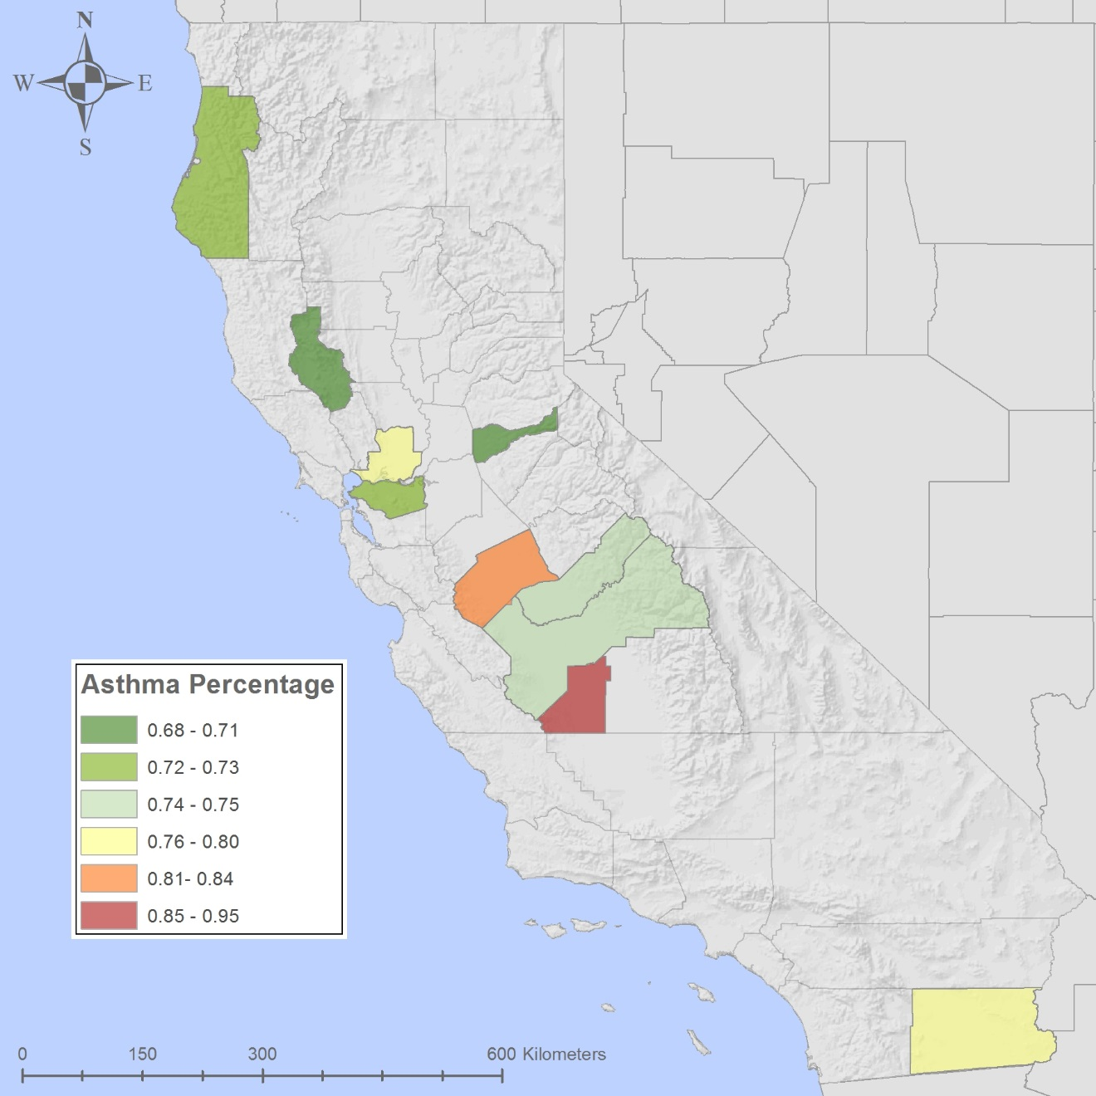
Figure 2: Top ten counties that have the highest rates of asthma hospitalizations
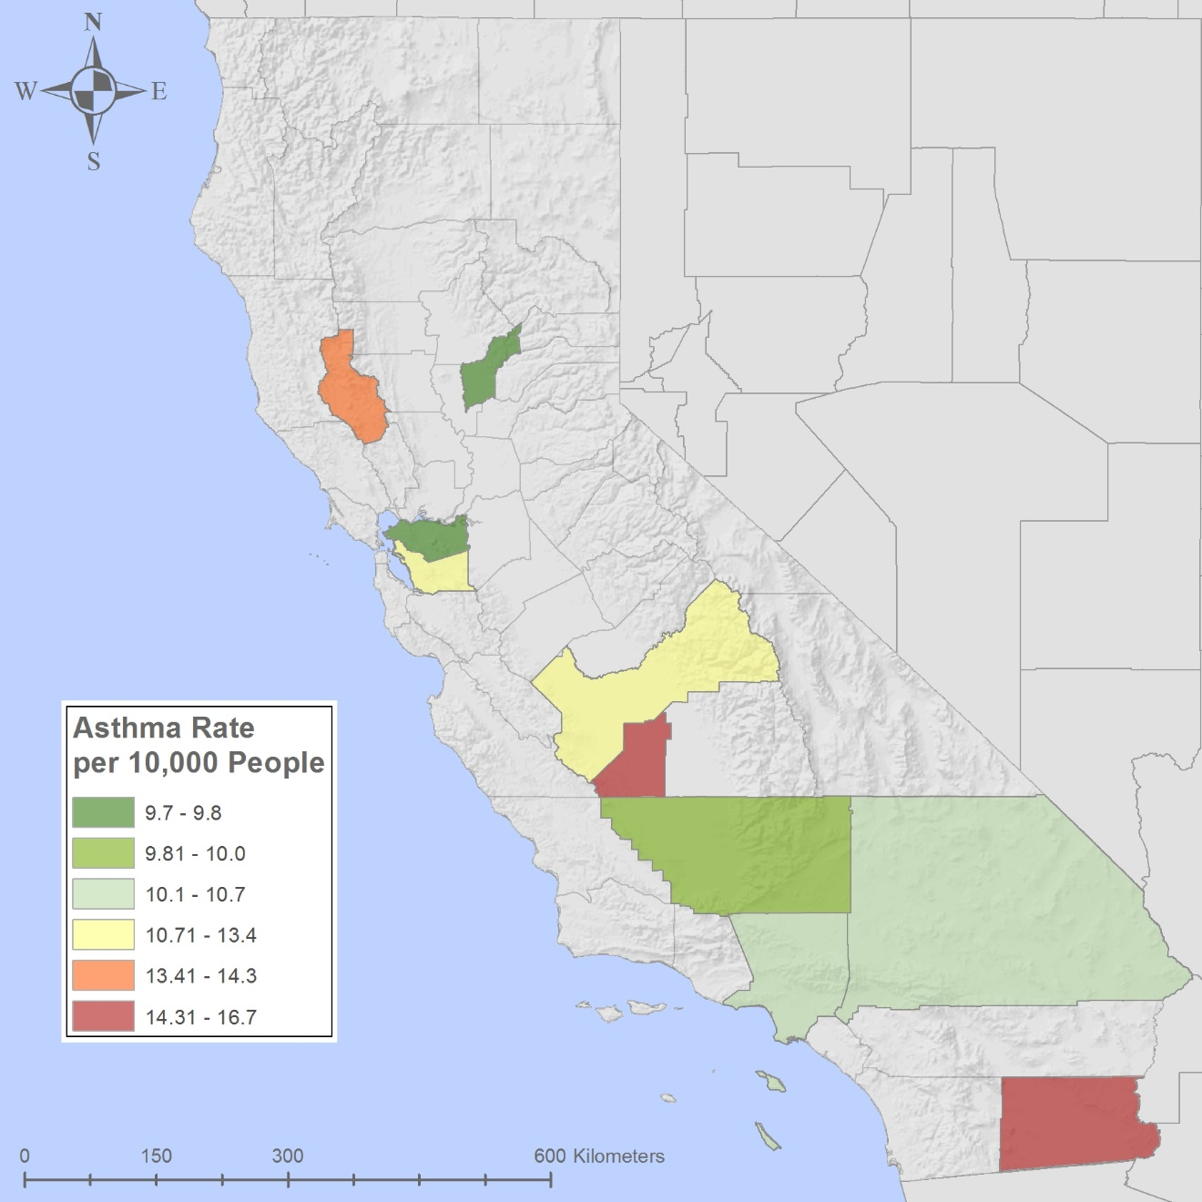
Figure 3:Top ten counties with highest asthma hospitalizations presented by California Breathing Organization in people per 10,000 people

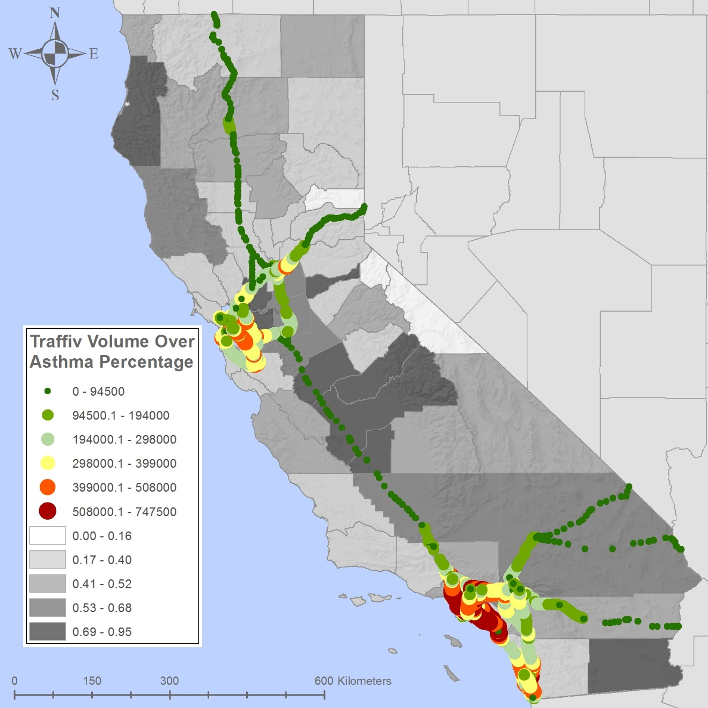
Figure 4: Interstate traffic through counties including a background of asthma percentage through all counties
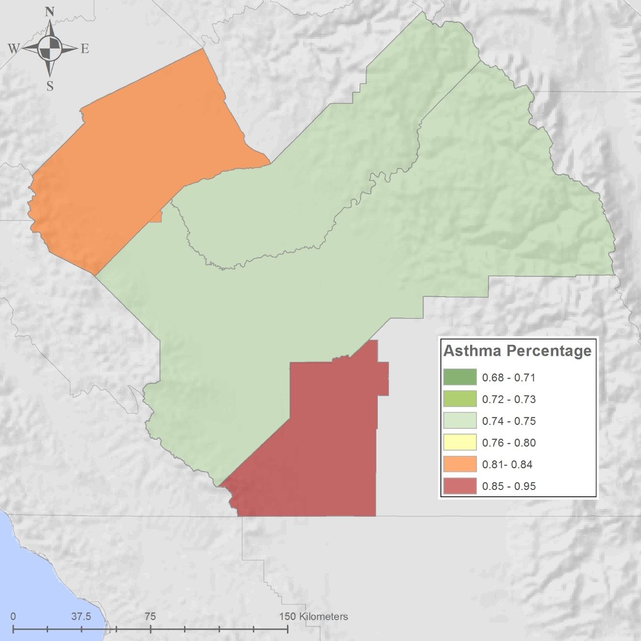
Fresno
Merced
Madera
Kings
Figure 5: Two counties with the highest rates of asthma hospitalization surrounded by other high asthma counties

Conclusion
In this project, we analyzed and compared asthma hospitalizations in California with traffic volume on interstates. There was no correlation between asthma and interstates. This project would have been better done if thorough research had been done on asthma. Asthma is caused in part by pollen; our analysis showed the highest causes of asthma were within the San Joaquin Valley air basin which is within the Central Valley, or the agriculture center of California. An improvement on this project would be to analyze asthma hospitalization with agriculture cities.

Bibliography
"Asthma and Air Pollution." Asthma and Air Pollution. Environmental Protection Agency, n.d.
Web. 28 Apr. 2016.
"Asthma ED Visit Rates by County 2012." California Department of Public Health Geospatial
"Asthma Hospitalizations, All Ages, 2012." N.p., n.d. Web. 05 May 2016.
"Base_Maps/Topo_Hillshade (MapServer)."Base_Maps/Topo_Hillshade (MapServer). N.p., n.d.
Web. 05 May 2016.
"California Relative Humidity Map." Air Sports. N.p., n.d. Web. 21 Apr. 2016.
Galloway, Devin, and Francis S. Riley. San Joaquin Valley, California. Menlo Park, California:
U.S Geological Survey, 2016. PDF.
"Geography." Cartographic Boundary Shapefiles. N.p., n.d. Web. 05 May 2016.
Resources. California Department of Public Health California Breathing Asthma Program, 6 Apr.
2016. Web. 21 Apr. 2016.
Base map of North America Continent provided by lab instructor

